Plan to implement changes

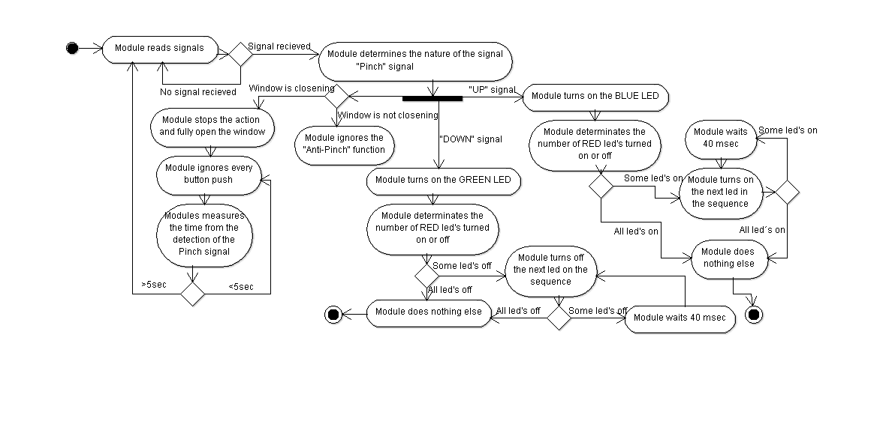

Based on the previous image, the best plan to implement Software changes will step by step. Following the next sequence; once defined our directions, functions and variables.

0.- Before start our code, it is necessary to map the different function to use.

1.- Starting establishing the digital inputs connected with the buttons.

2.- As a second step, the best approach for the module will be establish ten digital outputs.

3.- When the Outputs and inputs were defined, write and probe our functions. With special care in the interactions between them and the possible input combination.

4.- Once established the input for every function and its treatment, we will proceed to identify the write on the output without considering time for this step

5.- Now considering response time, the code is modified to add this functionalities.

6.- Once our window open and close according to the required time, it is time to write down our OneTouch Function.

7.- Now it is time to integrate all our functions into one code file.